Merriam-Webster dictionary defines oral history as: tape-recorded historical information obtained in interviews concerning personal experiences and recollections or the study of such information. What can’t be included in a dictionary definition is the most essential part of what oral history really is. Oral history has so many benefits because it provides firsthand accounts. History is often looked at based on how it affected society as a whole, or a group of people. Through oral history, the focus is on how events affected an individual. This allows for a much greater understanding of the impact of things that happened in the past, and how they changed the future of that person. The interviews also allow comparisons to be made between the stories of different people. This can show us how different circumstances change how the events play out. To further explain the value of oral history and everything that can be learnt from it, the stories of three WWII veterans with similar experiences will be compared.
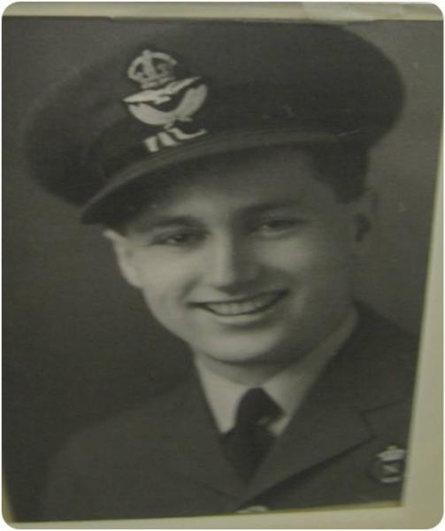
Jim Eddy was born in 1921 and was 20 years old when he decided to join the air force. He described the air force as “cool”, and said that “everyone wanted to get into the air force”, or they may be drafted into the army. Mr. Eddy was a navigator for the RCAF in squadron 419. Jim and his crew of 7 flew in a Lancaster with the job of bombing different targets in Germany. Mr. Eddy’s strongest memory is when a German plane got under their plane and shot up at them. The plane caught fire and the pilot told the crew they needed to jump out. The hatch at the front of the plane was stuck, but Mr. Eddy explained that “all of a sudden one of the windows blew out and I pulled myself out and jumped out.” After landing on the ground, he was eventually taken to a Luftwaffe airport and he was moved to a POW camp in Germany.
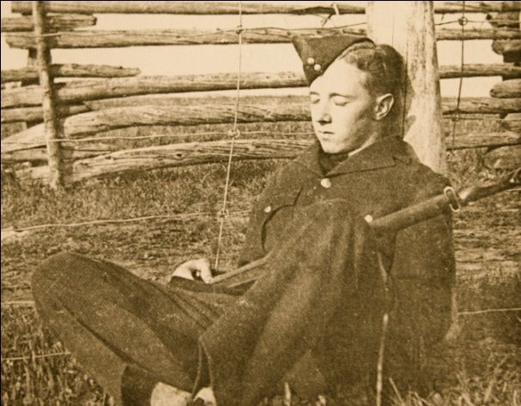
Fred Davies was born in Halifax, Nova Scotia. Like Eddy, Davies enlisted in the RCAF, and was selected to be a navigator. Davies was a member of the Pathfinders Force, and his job was to set flares at the targets so the main bombing force (which included Eddy) could hit their target s. Although being in the Pathfinders was extremely dangerous, Eddy and his crew managed to fly 46 missions. On the 46th mission, a fighter plane blew off one of their Lancaster’s engines and the crew had to bail out. After avoiding the being caught for a while, Davies was turned in to the Gestapo and became a POW at Stalag Luft III.
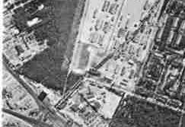
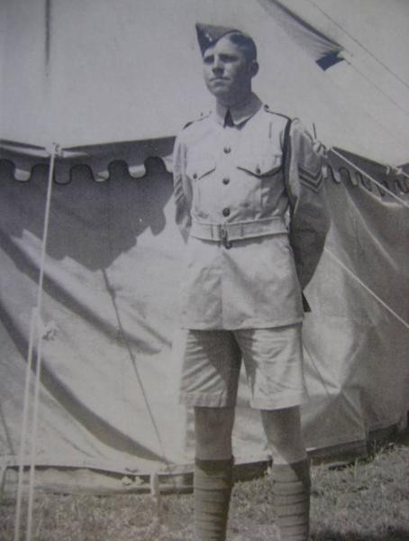
George MacDonnell was born in Edmonton Alberta in 1922. Growing up in a family with a military background, he was a member of the militia before WWII started. Therefore, when war broke out, he was a part of the first group called to the forces. Since he was only 17 at the time, he lied about his age to be able to join. Being accustomed to how the army worked, MacDonnell quickly moved up the rankings. Although he was expecting to be sent to Britain, he was sent to help defend Hong Kong. With all the odds against them, the forces in the Battle of Hong Kong had little hope of stopping a Japanese invasion. However, when they did come, the Canadians never gave up. Eventually, the Governor of the island surrendered, and MacDonnell and the troops in Hong Kong were taken as POWs.
Mr. Eddy, Mr. Davies, and Mr. MacDonnell were all taken as POW during WWII. However, their stories of their time as POW clearly show that their experiences were very different. Mr. Eddy and Mr. Davies were POW in German camps. Mr. Eddy explained that “You were behind wires, it was very demoralizing, there was nothing to do, they can’t make you work, and the food was terrible.” The food Mr. Eddy received in his camp was bread, coffee and sour soup. They also received Red Cross parcels that contained things like chocolate, cigarettes, and tea. Mr. MacDonnell’s situation was very different. “We were on a starvation diet from day one. The Japanese fed us about 1200 calories a day. We were placed on a diet that was eventually, after about four years or five years, going to starve us to death.” Another striking difference is that while Eddy specifically says that they couldn’t make them work, MacDonnell describes how in his camp they were forced into slave labour and he worked in underground iron mines. Eddy and Davies were liberated by General Patton, but in MacDonnell’s POW camp, if there was a possibility they could be liberated, the Japanese commander was told to kill every POW. Fortunately, the war came to an end before this could be the reality for all of the POW.
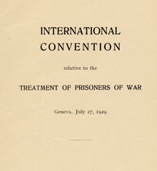
So why was there such a difference in how these men were treated? In the 1929 Geneva Convention, a set of rules were laid out for how Prisoners of War should be treated. This is the reason that Mr. Eddy said that the Germans could not make them work. It is also a reason why the POW in German camps were marched away from the dangerous battle areas. But the Japanese did not sign this, so Mr. MacDonnell had to fear that if he was not killed by starvation or disease, as 30% of the other Japanese POWs were, that he could be killed by the Allies as they dropped their bombs. Perhaps if Mr. MacDonnell had waited another year to join the services, or Mr. Davies or Mr. Eddy had joined a little sooner, their positions could have been reversed.
redcross.int
Oral history is what allows these comparisons to be made. It is in the detail of people’s stories that enables you to learn some of the most interesting, and often overlooked things about history. It also lets you see the tears of Mr. Eddy when he talks about the 6 close friends he lost that day their plane was shot down, the horror in his face when he recounted visiting Dachau, or the passion Mr. MacDonnell shared when he described how brave and noble the Canadian troops were. It can be argued that the prejudices that appear in these stories are a disadvantage of oral history. However, they simply add another element to the story and can show you the way society viewed other groups or people at the time. Faulty memory can also be seen as a disadvantage to oral history, but this can put emphasis on what the storyteller does remember, and displays how important certain things are to them. People are what make up history, and by listening to direct stories from survivors of events in the past, you can more effectively analyze, remember, and learn from them, to make a better future.

