The Sinking of the Punjabi
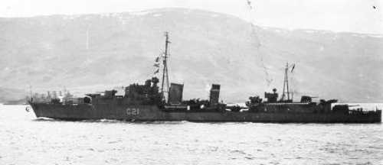
May 1st, 1942 was a fateful day for the Punjabi as this was the date that the ship crashed. What seemed to be an ordinary day suddenly turned into a terrible and tragic event. The H.M.S. Punjabi was a British destroyer working in the North Atlantic protecting the merchant marine that carried supplies back and forth between the Allies.
The HMS Punjabi
The Punjabi had been travelling with, the H.M.S. King George V (the flag ship of the fleet), the carrier H.M.S. Victoria, the battleship the U.S.S. Washington, and two cruisers the U.S.S. Wichita and the U.S.S. Tuscaloosa on a very important mission. They were escorting convoy P.Q. 15 on its way to Murmansk Russia carrying vital supplies for the war effort. Before this the Punjabi had been in charge of making anti-submarine patrols. There were about 250 sailors on board.
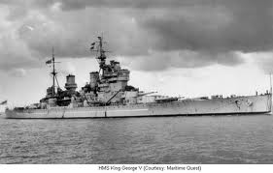
The setting for the accident was in the North Atlantic, where it is very cold. On that day Bill Campbell, a seaman on board the H.M.S. King George V, remembers the sea being extremely calm. Usually the seas in the North Atlantic in that area were rough with the waves “as tall as houses”. The ships involved were very big and heavy and needed a lot of room and time to turn around or change course and when they are close together it is even more difficult. They have a series of signals and protocols that they use to tell each other what they are doing so they avoid steering problems.
HMS King George V

At 15:45 hours (3:45 P.M.) the King George V ran straight through the Punjabi after narrowly avoiding hitting the Inglefield (another ship in the convoy). The reason that the Punjabi got hit was that it had changed course to avoid a floating mine. Mr. Campbell also thought that there was a mix-up in the signals between the ships that tell each other when and where they are changing course. The Punjabi had been following the Inglefield and because of the mine crossed straight over into the path of the King George V. At first the men aboard both the Punjabi and the King George V thought they had been hit by a torpedo. When the men on the Punjabi looked around they could see no enemy. Then they spotted the King George V and realized the “enemy” was one of their own. Life rafts were immediately deployed by all of the other ships and luckily they saved about 206 of the 250 men on board. The ships “covered the sea” in life rafts and the calmness of the water also helped save many lives. Although the initial crash was horrible Mr. Campbell remembers the sound of the after explosion of the ship’s engines and all the ammunition on board as being almost as bad.
This was an important event because it demonstrates how the different armed forces worked together, in this case the British and the American navies. It also shows that there were some sad deaths in WWII caused by accidents. In conclusion, this is a topic that I have never learnt anything about before now and found very interesting.

